Aim: Write the Verilog code for following latches,(i) SR latch and (ii) D latch
IDE: EDA Playground
Theory:

A Latch is a special type of logical circuit. The latches have low and high two stable states. Due to these states, latches also refer to as bistable-multivibrators. A latch is a storage device that holds the data using the feedback lane. The latch stores 1 -bit until the device set to 1. The latch changes the stored data and constantly trials the inputs when the enable input set to 1.
Based on the enable signal, the circuit works in two states. When the enable input is high, then both the inputs are low, and when the enable input is low, both the inputs are high.
Types of Latches
There are various types of latches used in digital circuits which are as follows:

- SR Latch
- D Latch
- JK Latch
- T Latch
- Gated SR Latch
- Gated D latch
SR Latch
The SR latch is a special type of asynchronous device which works separately for control signals. It depends on the S-states and R-inputs. The SR latch design by connecting two NOR gates with a cross loop connection. The SR latch can also be designed using the NAND gate. Below are the circuit diagram and the truth table of the SR latch

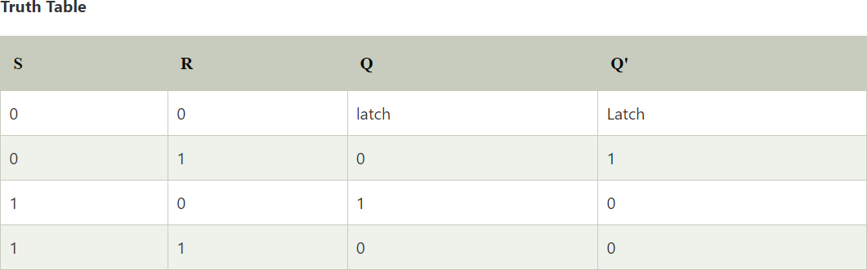

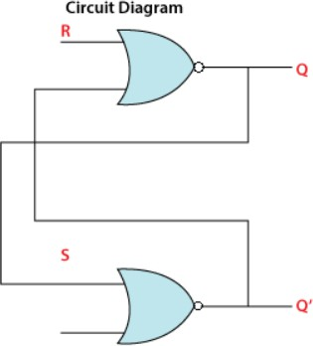
D Latch
The D latch is the same as D flip flop. The only difference between these two is the ENABLE input. The output of the latch is the same as the input passed to the Data input when the ENABLE input set to 1. At that time, the latch is open, and the path is transparent from input to output. If the ENABLE input is set to 0, the D latch's output is the last value of the latch, i.e., independent from the input D, and the latch is closed. Below are the circuit diagram and the truth table of the D latch.

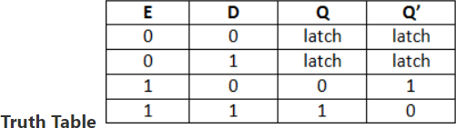

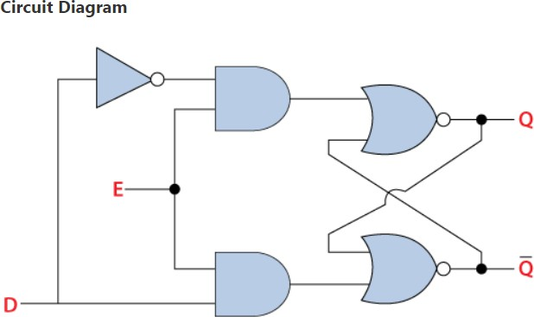

Pre Lab Exercise:

  - What is Latches?
A latch is a basic digital memory device used to store one bit of information. It is a type of bistable circuit, which means it has two stable states (0 or 1). A latch can hold its output value until the input signal changes. Latches are level-sensitive devices, meaning their output changes when the input is active. They are commonly used in sequential circuits to store data temporarily.
  - what is need of latches?
Latches are needed to store data in digital circuits. They help in maintaining a particular state until new input is given. Latches are useful when temporary storage of information is required. They also help in synchronization and controlling the flow of data in sequential logic circuits. Without latches, circuits would not be able to remember previous outputs.

  - How latch are useful in any logic circuit?
Latches are useful in logic circuits because they provide memory. They can store output values and use them later in the circuit operation. Latches are used in registers, flip-flops, counters, and memory units. They help in designing sequential circuits where the output depends on both present input and previous output. Thus, latches are important building blocks in digital electronic systems.

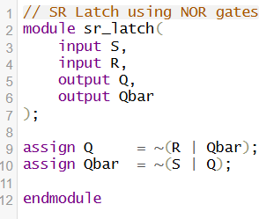
Verilog Code for SR Latch:

Test-bench for SR Latch:
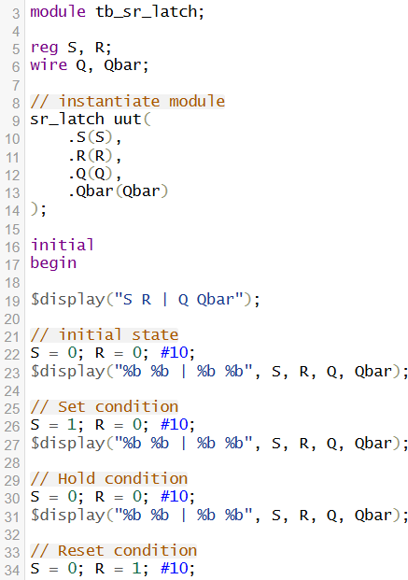

Results for SR Latch:
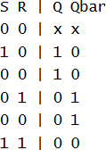

Observation and Result Analysis:
The SR latch was successfully designed and simulated using Verilog HDL in EDA Playground. The circuit stores one bit of data and operates based on the Set (S) and Reset (R) inputs. When S = 1, the output is set to 1, and when R = 1, the output is reset to 0. When both inputs are 0, the latch holds the previous state, showing its memory property. The simulation results verified the correct working of the SR latch, proving that it is an important basic building block in sequential logic circuits such as flip-flops, registers, and memory units.

Post Lab Exercise:
- Write verilog code, test bench and output for T latch
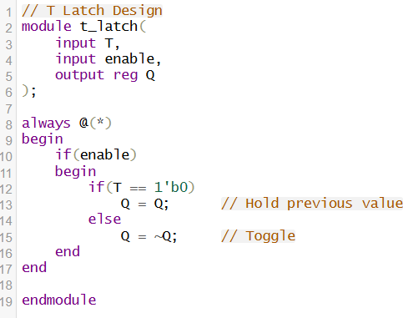
Verilog Code:

Testbench:

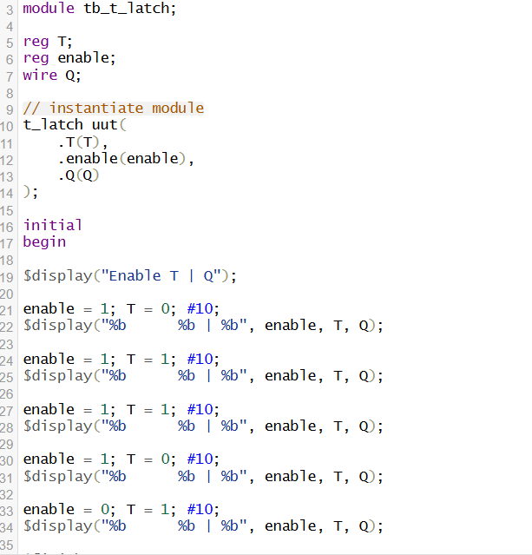

Results:
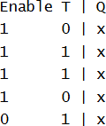

- Write Verilog code, test bench and output for JK -Latch
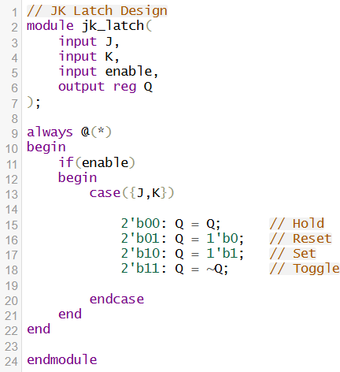
Verilog Code:
Testbench:
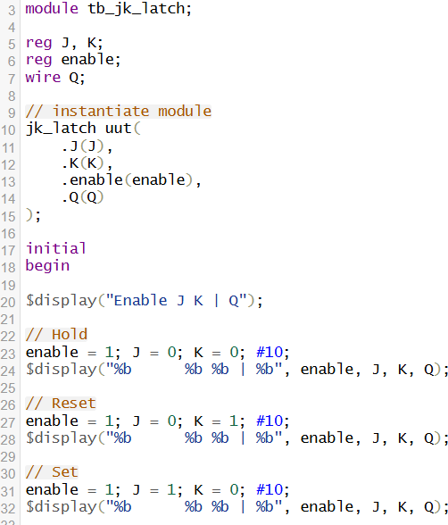

Results:
